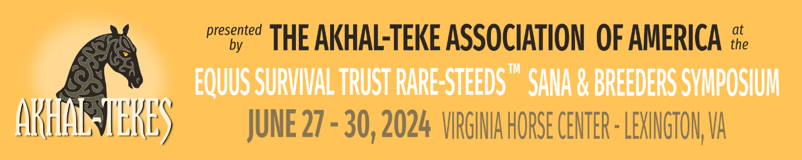

Dressage : Sunday Northern Arenas 8 – 12am
Horses and Ponies compete in the same classes but are pinned separately.
Horses and Ponies are not judged against each other but have their individual divisions.
Each individual Class will have placings for each Division Horse/Pony (ribbons 1st -6th)

- Intro A
- Intro B
- Intro C
- Training 1
- Training 2
- Training 3
- First Level Test 1
- First Level Test 2
- First Level Test 3
- Second Level TOC
- Third Level TOC
- Fourth Level TOC
- FEI TOC
- Western Dressage TOC

